DAY - 7

ATTRITION ASSIGNMENT

STEP 1 = LAUNCHING : import pandas as p import numpy as n import matpolib.pyplot as pl data=pd.read_csv(“general_data.csv”)

->To find column names .

data.columns

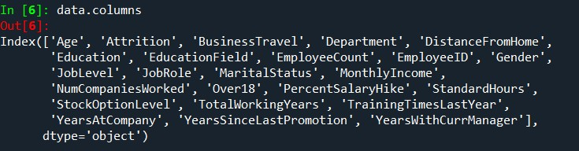

->To find the data of first 5 rows.

data.head( )

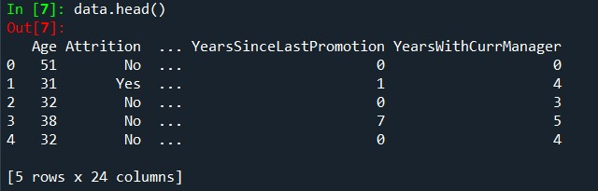

STEP 2 = DATA TREATMENT :

->To find out null values in the table.

data.isnull( )

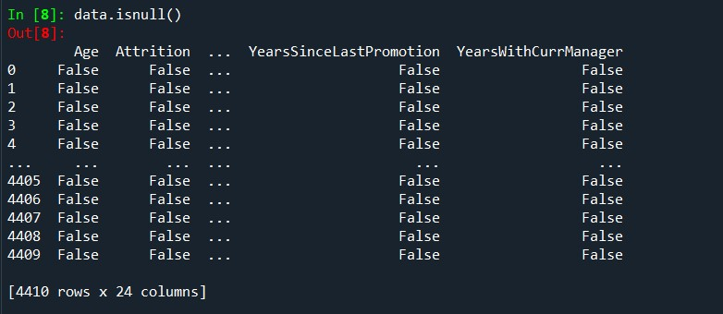

->To find out duplicated values of table.

data.duplicated( )

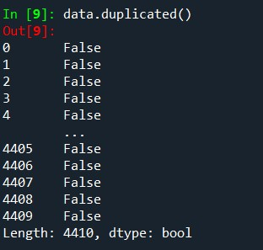

>To drop all duplicated values of the table.

data.drop_duplicates( )

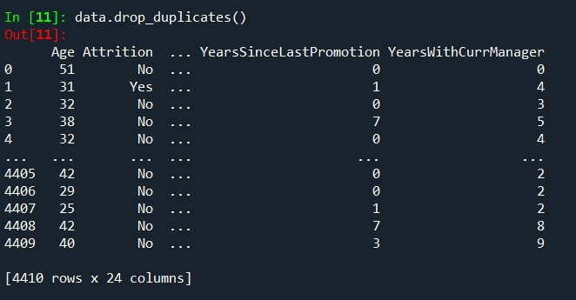

STEP 3 = UNIVARIATE ANALYSIS :

->To describe the whole table.

data1=data[['Age', 'Attrition', 'BusinessTravel', 'Department',

'DistanceFromHome','Education', 'EducationField', 'EmployeeCount',

'EmployeeID', 'Gender','JobLevel', 'JobRole', 'MaritalStatus', 'MonthlyIncome',

'NumCompaniesWorked', 'Over18', 'PercentSalaryHike',

'StandardHours','StockOptionLevel', 'TotalWorkingYears',

'TrainingTimesLastYear','YearsAtCompany', 'YearsSinceLastPromotion',

'YearsWithCurrManager']].describe( )

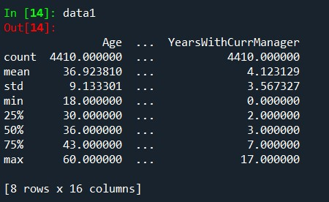

->To find out median of each column .

data2=data[['Age', 'Attrition', 'BusinessTravel', 'Department',

'DistanceFromHome','Education', 'EducationField', 'EmployeeCount',

'EmployeeID', 'Gender','JobLevel', 'JobRole', 'MaritalStatus', 'MonthlyIncome',

'NumCompaniesWorked', 'Over18', 'PercentSalaryHike',

'StandardHours','StockOptionLevel', 'TotalWorkingYears',

'TrainingTimesLastYear','YearsAtCompany', 'YearsSinceLastPromotion', 'YearsWithCurrManager']].median( )

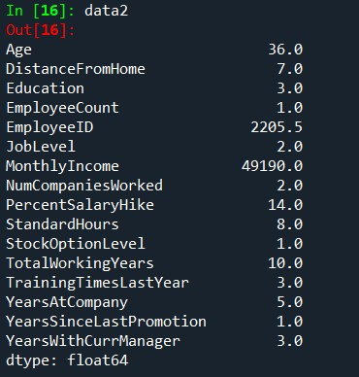

>To find out mean of each column.

data3=data[['Age', 'Attrition', 'BusinessTravel', 'Department',

'DistanceFromHome','Education', 'EducationField', 'EmployeeCount',

'EmployeeID', 'Gender','JobLevel', 'JobRole', 'MaritalStatus', 'MonthlyIncome',

'NumCompaniesWorked', 'Over18', 'PercentSalaryHike',

'StandardHours','StockOptionLevel', 'TotalWorkingYears',

'TrainingTimesLastYear','YearsAtCompany', 'YearsSinceLastPromotion', 'YearsWithCurrManager']].mean( )

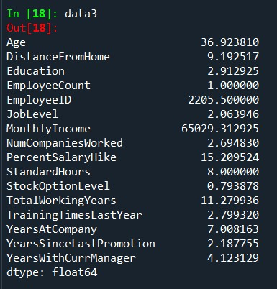

->To find out mode.

data4=data[['Age', 'Attrition', 'BusinessTravel', 'Department',

'DistanceFromHome','Education', 'EducationField', 'EmployeeCount',

'EmployeeID', 'Gender','JobLevel', 'JobRole', 'MaritalStatus',

'MonthlyIncome', 'NumCompaniesWorked', 'Over18',

'PercentSalaryHike', 'StandardHours','StockOptionLevel',

'TotalWorkingYears', 'TrainingTimesLastYear','YearsAtCompany',

'YearsSinceLastPromotion', 'YearsWithCurrManager']].mode( )

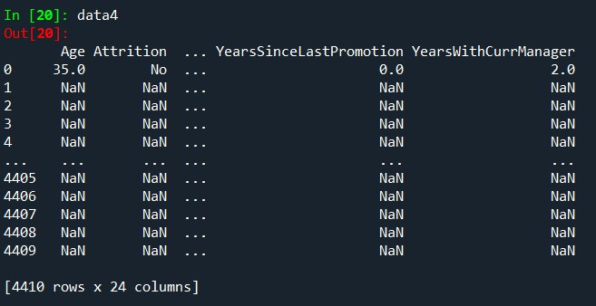

->To find variance of each column.

data5=data[['Age', 'Attrition', 'BusinessTravel', 'Department',

'DistanceFromHome','Education', 'EducationField', 'EmployeeCount',

'EmployeeID', 'Gender','JobLevel', 'JobRole', 'MaritalStatus',

'MonthlyIncome', 'NumCompaniesWorked', 'Over18',

'PercentSalaryHike', 'StandardHours','StockOptionLevel',

'TotalWorkingYears', 'TrainingTimesLastYear','YearsAtCompany',

'YearsSinceLastPromotion', 'YearsWithCurrManager']].var( )

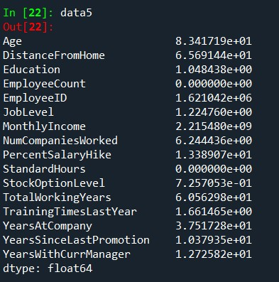

>To find skewness.

data6=data[['Age', 'Attrition', 'BusinessTravel', 'Department',

'DistanceFromHome','Education', 'EducationField', 'EmployeeCount',

'EmployeeID', 'Gender','JobLevel', 'JobRole', 'MaritalStatus', 'MonthlyIncome',

'NumCompaniesWorked', 'Over18', 'PercentSalaryHike',

'StandardHours','StockOptionLevel', 'TotalWorkingYears',

'TrainingTimesLastYear','YearsAtCompany', 'YearsSinceLastPromotion', 'YearsWithCurrManager']].skew( )

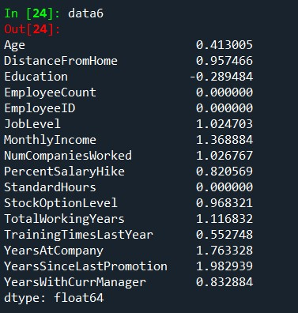

->To find out kurtosis.

data7=data[['Age', 'Attrition', 'BusinessTravel', 'Department',

'DistanceFromHome','Education', 'EducationField', 'EmployeeCount',

'EmployeeID', 'Gender','JobLevel', 'JobRole', 'MaritalStatus', 'MonthlyIncome',

'NumCompaniesWorked', 'Over18', 'PercentSalaryHike',

'StandardHours','StockOptionLevel', 'TotalWorkingYears',

'TrainingTimesLastYear','YearsAtCompany', 'YearsSinceLastPromotion', 'YearsWithCurrManager']].kurt( )

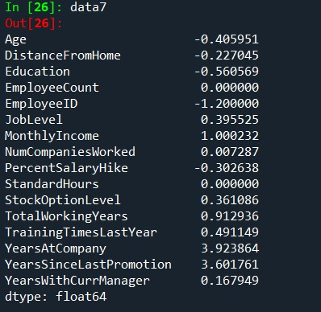

->To find standard deviation .

data8=data[['Age', 'Attrition', 'BusinessTravel', 'Department',

'DistanceFromHome','Education', 'EducationField', 'EmployeeCount',

'EmployeeID', 'Gender','JobLevel', 'JobRole', 'MaritalStatus', 'MonthlyIncome',

'NumCompaniesWorked', 'Over18', 'PercentSalaryHike',

'StandardHours','StockOptionLevel', 'TotalWorkingYears',

'TrainingTimesLastYear','YearsAtCompany', 'YearsSinceLastPromotion', 'YearsWithCurrManager']].std( )

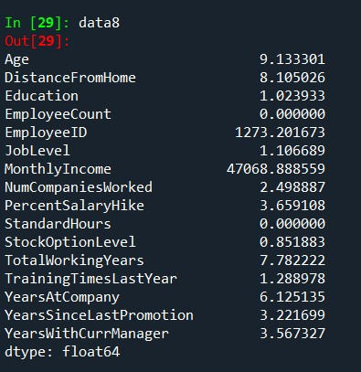

INFERENCE :

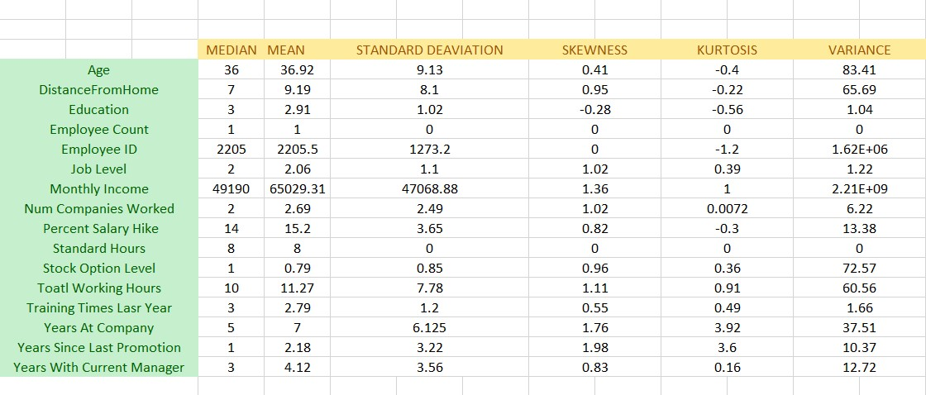

->All the above variables show positive skewness; while Age

&Mean_distance_from_home are leptokurtic and all other variables are platykurtic.

OUTLIERS :

There’s no regression found while plotting Age, MonthlyIncome, TotalWorkingYears , YearsAtCompany, etc., on a scatter plot.

box_plot=data.Age pl.boxplot(box_plot)

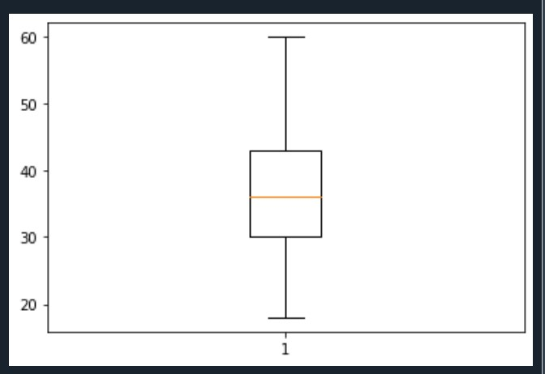

Age is normally distributed without any outliers

box_plot=data.MonthlyIncome pl.boxplot(box_plot)

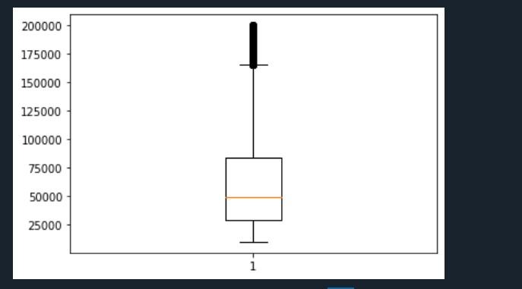

Monthly Income is Right skewed with several outliers box_plot=data.YearsAtCompany

pl.boxplot(box_plot)

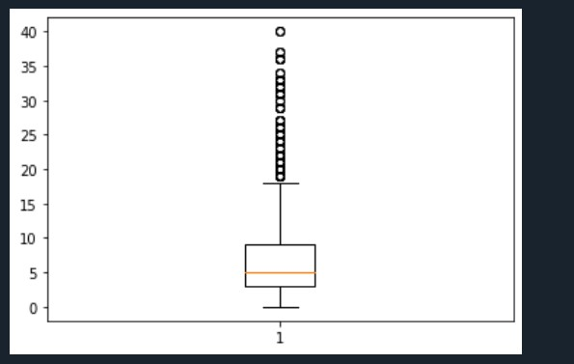

Years at company is also Right Skewed with several outliers observed.

# 4>STATISTICAL TEST ( MANN-WHITNEY)

import pandas as pd

data=pd.read_csv("general_data.csv") data.head()

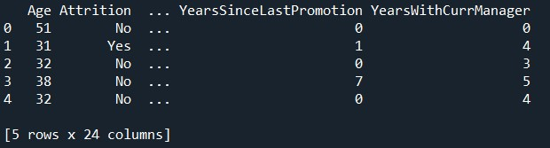

data.columns

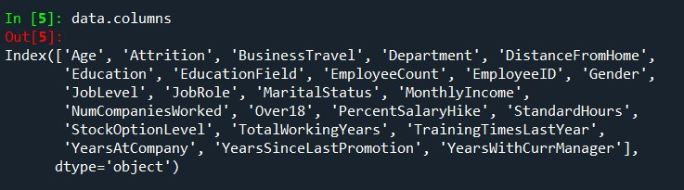

# MANN WHTNEY TEST

import pandas as pd

df=pd.read_csv('general_data.csv') dummy=pd.get_dummies(df['Attrition']) df2=pd.concat((df,dummy),axis=1) df2=df2.drop(['Attrition'],axis=1) df2=df2.drop(['No'],axis=1)

df2=df2.rename(columns={"Yes":"Attrition"}) df2.head()

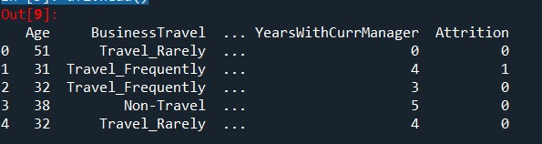

**ATTRITION VS DISTANCE FROM HOME.**

H0 = There is no significant difference between attrition yes and no for distance from home

HA= There is significant difference between attrition yes and no for distance from home

from scipy.stats import mannwhitneyu

stats,p=mannwhitneyu(df2.Attrition,df2.DistanceFromHome) print(stats,p)

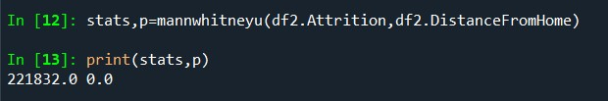

As the P value of 0.0 is < 0.05, the H0 is rejected and HA is accepted.

So there is difference in attrition and distance from home.

## **ATTRITION VS TOTAL WORKING YEARS**

H0 = There is no significant difference between attrition yes and no for total working years.

HA= There is significant difference between attrition yes and no for total working years. stats,p=mannwhitneyu(df2.Attrition,df2.TotalWorkingYears) print(stats,p)

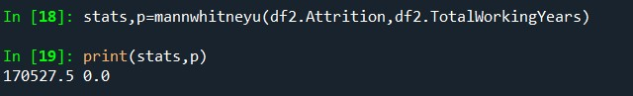

As the P value of 0.0 is < 0.05, the H0 is rejected and Ha is accepted.

So there is difference in attrition and total working years.

## **ATTRITION VS YEARS AT COMPANY**

H0 = There is no significant difference between attrition yes and no for years at company.

HA= There is significant difference between attrition yes and no for years at company.

stats,p=mannwhitneyu(df2.Attrition,df2.YearsAtCompany) print(stats,p)

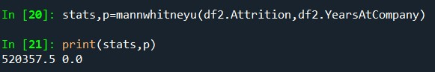

As the P value of 0.0 is < 0.05, the H0 is rejected and Ha is accepted.

So there is difference in attrition and years at company.

## **ATTRITION VS YEARS WITH CURRENT MANAGER**

H0 = There is no significant difference between attrition yes and no for years with current manager.

HA= There is significant difference between attrition yes and no for years with current manager.

stats,p=mannwhitneyu(df2.Attrition,df2.YearsWithCurrManager) print(stats,p)

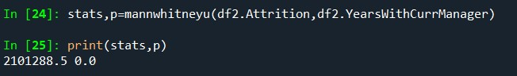

As the P value of 0.0 is < 0.05, the H0 is rejected and HA is accepted.

So there is difference in attrition and years with current manager.

# CORRELATION BETWEEN 2 VARIABLES

import pandas as pd df=pd.read_csv('general_data.csv')

## CORRELATION BETWEEN ATTRITION AND AGE

from scipy.stats import pearsonr stats,p=pearsonr(df2.Attrition,df2.Age) print(stats,p) if (stats==0):

print("NO CORRELATION")

elif(stats<0):

print("NEGETIVE CORRELATION")

else:

print("POSITIVE CORRELATION") import matplotlib.pyplot as plt plt.scatter(df2.Attrition,df2.Age)

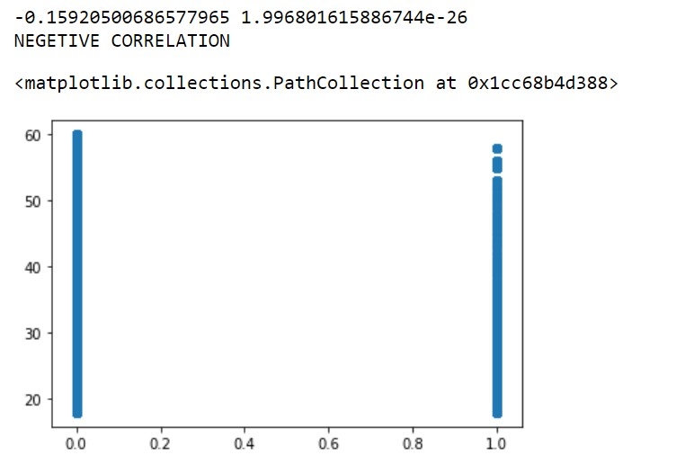

It is low negative correlation.

H0 = There is no significant difference between attrition and age.

HA = There is significant difference between attrition and age.

|  |  |
| --- | --- |
| As p value less than .05 so null hypothesis is rejected , so there is significant difference between | |
| attrition and age. |  |

## CORRELATION BETWEEN ATTRITION AND YEARS AT COMPANY

stats,p=pearsonr(df2.Attrition,df2.YearsAtCompany)

print(stats,p) if (stats==0): print("NO CORRELATION")

elif(stats<0):

print("NEGETIVE CORRELATION")

else:

print("POSITIVE CORRELATION") plt.scatter(df2.Attrition,df2.YearsAtCompany)

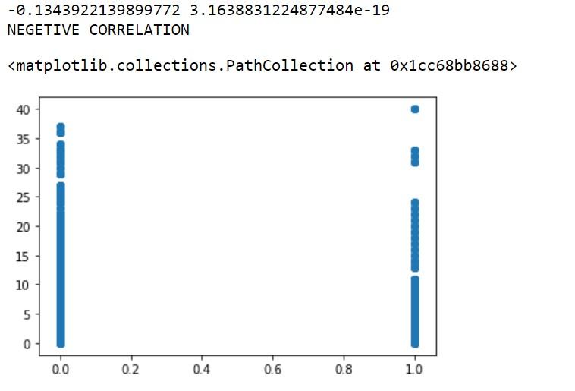

It is low negative correlation.

H0 = There is no significant difference between attrition and years at company.

HA = There is significant difference between attrition and years at company.

|  |  |
| --- | --- |
| As p value less than .05 so null hypothesis is rejected . so there is significant difference between | |
| attrition and years at company. |  |

### CORRELATION BETWEEN ATTRITION AND YEARS SINCE LAST PROMOTION

stats,p=pearsonr(df2.Attrition,df2.YearsSinceLastPromotion)

print(stats,p) if (stats==0): print("NO CORRELATION")

elif(stats<0):

print("NEGETIVE CORRELATION")

else:

print("POSITIVE CORRELATION") plt.scatter(df2.Attrition,df2.YearsSinceLastPromotion)

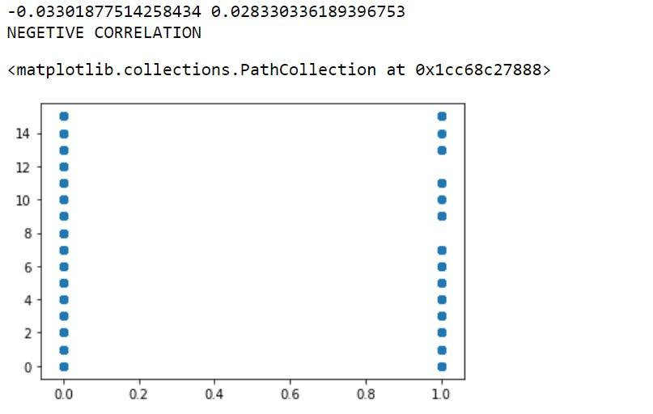

It is low negative correlation.

H0 = There is no significant difference between attrition and years since last promotion.

HA = There is significant difference between attrition and years since last promotion.

|  |  |
| --- | --- |
| As p value less than .05 so null hypothesis is rejected , so there is significant difference between | |
| attrition and years since last promotion | . |

### CORRELATION BETWEEN ATTRITION AND TRAINING TIMES LAST YEAR

stats,p=pearsonr(df2.Attrition,df2.TrainingTimesLastYear) print(stats,p) if (stats==0): print("NO CORRELATION")

elif(stats<0):

print("NEGETIVE CORRELATION")

else:

print("POSITIVE CORRELATION") plt.scatter(df2.Attrition,df2.TrainingTimesLastYear)

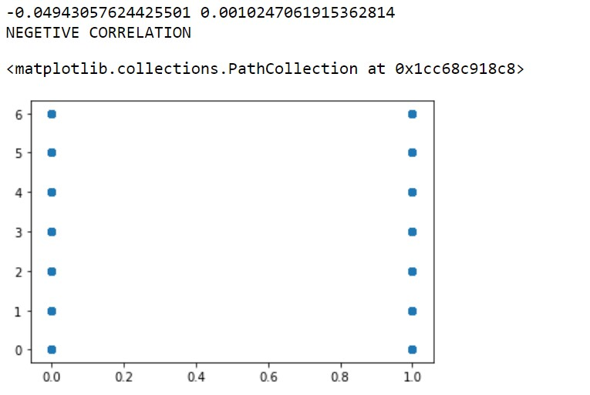

It is low negative correlation.

H0 = There is no significant difference between attrition and training times last year.

HA = There is significant difference between attrition and training times last year.

|  |  |
| --- | --- |
| As p value less than .05 so null hypothesis is rejected , so there is significant difference between | |
| attrition and training times last year . |  |

### CORRELATION BETWEEN ATTRITION AND STOCK OPTION LEVEL

stats,p=pearsonr(df2.Attrition,df2.StockOptionLevel) print(stats,p) if (stats==0): print("NO CORRELATION")

elif(stats<0):

print("NEGETIVE CORRELATION")

else:

print("POSITIVE CORRELATION") plt.scatter(df2.Attrition,df2.StockOptionLevel)

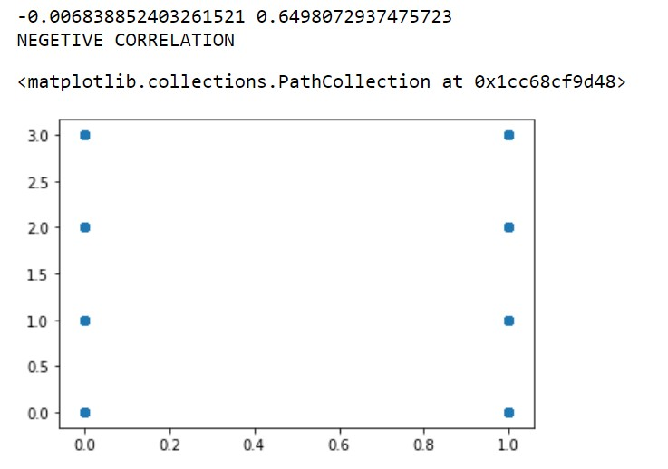

It is low negative correlation.

H0 = There is no significant difference between attrition and stock option level.

HA = There is significant difference between attrition and stock option level.

|  |  |
| --- | --- |
| As p value more than .05 so null hypothesis is accepted , so there is no significant difference | |
| between attrition and stock option level. |  |

## CORRELATION BETWEEN ATTRITION AND PERCENTAGE SALARY HIKE

stats,p=pearsonr(df2.Attrition,df2.PercentSalaryHike) print(stats,p) if (stats==0): print("NO CORRELATION")

elif(stats<0):

print("NEGETIVE CORRELATION")

else:

print("POSITIVE CORRELATION") plt.scatter(df2.Attrition,df2.PercentSalaryHike)

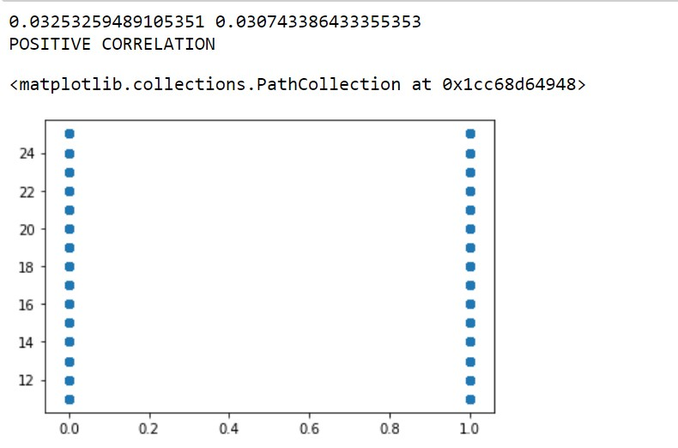

It is low positive correlation.

H0 = There is no significant difference between attrition and percent salary hike.

HA = There is significant difference between attrition and percent salary hike.

|  |  |
| --- | --- |
| As p value less than .05 so null hypothesis is rejected , so there there is significant difference | |
| between attrition and percent salary hike. |  |

## CORRELATION BETWEEN ATTRITION AND JOB LEVEL

stats,p=pearsonr(df2.Attrition,df2.JobLevel) print(stats,p) if (stats==0): print("NO CORRELATION")

elif(stats<0):

print("NEGETIVE CORRELATION")

else:

print("POSITIVE CORRELATION") plt.scatter(df2.Attrition,df2.JobLevel)

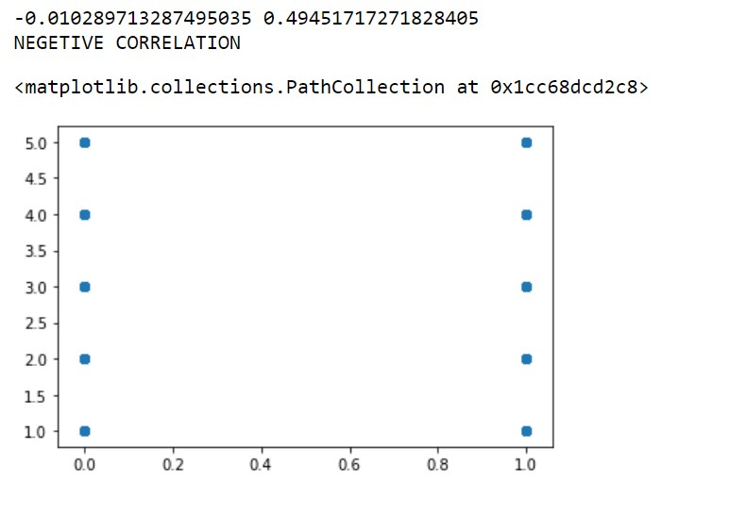

It is low negative correlation.

H0 = There is no significant difference between attrition and job level.

HA = There is significant difference between attrition and job level.

|  |  |
| --- | --- |
| As p value more than .05 so null hypothesis is accepted , so there there is no significant | |
| difference between attrition and job level | . |

### CORRELATION BETWEEN ATTRITIONA ND DISTANCE FROM HOME

stats,p=pearsonr(df2.Attrition,df2.DistanceFromHome)

print(stats,p) if (stats==0): print("NO CORRELATION")

elif(stats<0):

print("NEGETIVE CORRELATION")

else:

print("POSITIVE CORRELATION") plt.scatter(df2.Attrition,df2.DistanceFromHome)

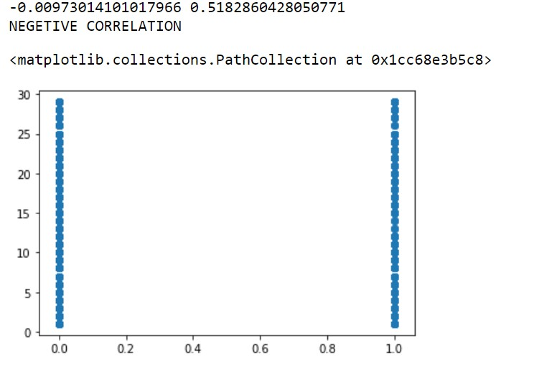

It is low negative correlation.

H0 = There is no significant difference between attrition and distance from home.

HA = There is significant difference between attrition and distance from home.

|  |  |
| --- | --- |
| As p value more than .05 so null hypothesis is accepted , so there is no significant difference | |
| between attrition and distance from home | . |

### CORRELATION BETWEEN ATTRITION AND EDUCATION

stats,p=pearsonr(df2.Attrition,df2.Education) print(stats,p) if (stats==0): print("NO CORRELATION")

elif(stats<0):

print("NEGETIVE CORRELATION")

else:

print("POSITIVE CORRELATION") plt.scatter(df2.Attrition,df2.Education)

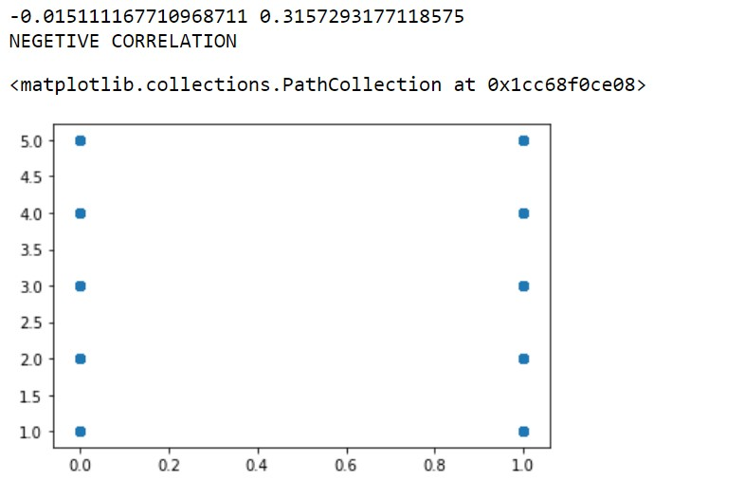

It is low negative correlation.

H0 = There is no significant difference between attrition and education.

HA = There is significant difference between attrition and education.

|  |  |
| --- | --- |
| As p value more than .05 so null hypothesis is accepted , so there is no significant difference | |
| between attrition and education. |  |

### CORRELATION BETWEEN ATTRTION AND YEARS WITH CURRENT MANAGER

stats,p=pearsonr(df2.Attrition,df2.YearsWithCurrManager)

print(stats,p) if (stats==0): print("NO CORRELATION")

elif(stats<0):

print("NEGETIVE CORRELATION")

else:

print("POSITIVE CORRELATION") plt.scatter(df2.Attrition,df2.YearsWithCurrManager)

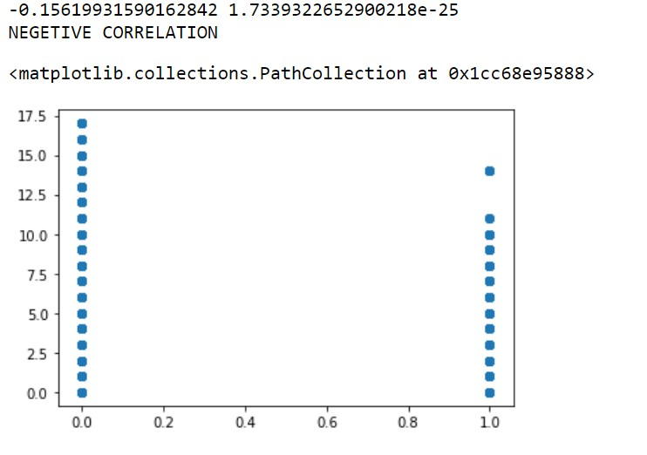

It is low negative correlation.

H0 = There is no significant difference between attrition and years with current manager.

HA = There is significant difference between attrition and years with current manager.

|  |  |
| --- | --- |
| As p value less than .05 so null hypothesis is rejected , so there is significant difference between | |
| attrition and years with current manager. |  |